Hans Spemann and Hilde Mangold: Primary Embryonic Induction
The most spectacular transplantation experiments were published by Hans Spemann and Hilde Mangold in 1924.* They showed that, of all the tissues in the early gastrula, only one has its fate determined. This self-differentiating tissue is the dorsal lip of the blastopore, the tissue derived from the gray crescent cytoplasm. When this dorsal lip tissue was transplanted into the presumptive belly skin region of another gastrula, it not only continued to be blastopore lip, but also initiated gastrulation and embryogenesis in the surrounding tissue (Figure 10.20). Two conjoined embryos were formed instead of one!
In these experiments, Spemann and Mangold used differently pigmented embryos from two newt species: the darkly pigmented Triturus taeniatus and the nonpigmented Triturus cristatus. So when Spemann and Mangold prepared these transplants, they were able to readily identify host and donor tissues on the basis of color.† When the dorsal lip of an early T. taeniatus gastrula was removed and implanted into the region of an early T. cristatus gastrula fated to become ventral epidermis (belly skin), the dorsal lip tissue invaginated just as it would normally have done (showing self-determination), and disappeared beneath the vegetal cells. The pigmented donor tissue then continued to self-differentiate into the chordamesoderm (notochord) and other mesodermal structures that normally form from the dorsal lip. As the new donor-derived mesodermal cells moved forward, host cells began to participate in the production of the new embryo, becoming organs that normally they never would have formed. In this secondary embryo, a somite could be seen containing both pigmented (donor) and unpigmented (host) tissue. Even more spectacularly, the dorsal lip cells were able to interact with the host tissues to form a complete neural plate from host ectoderm. Eventually, a secondary embryo formed, face to face with its host. These technically difficult experiments have been repeated using nuclear markers, and the results of Spemann and Mangold have been confirmed (Smith and Slack 1983; Recanzone and Harris 1985).
Spemann (1938) referred to the dorsal lip cells and their derivatives (notochord, prechordal mesoderm) as the organizer because (1) they induced the host's ventral tissues to change their fates to form a neural tube and dorsal mesodermal tissue (such as somites), and (2) they organized host and donor tissues into a secondary embryo with clear anterior-posterior and dorsal-ventral axes. He proposed that during normal development, these cells organize the dorsal ectoderm into a neural tube and transform the flanking mesoderm into the anterior-posterior body axis. It is now known (thanks largely to Spemann and his students) that the interaction of the chordamesoderm and ectoderm is not sufficient to “organize” the entire embryo. Rather, it initiates a series of sequential inductive events. As discussed in Chapter 6, the process by which one embryonic region interacts with a second region to influence that second region's differentiation or behavior is called induction. Because there are numerous inductions during embryonic development, this key induction wherein the progeny of dorsal lip cells induce the dorsal axis and the neural tube is traditionally called primary embryonic induction
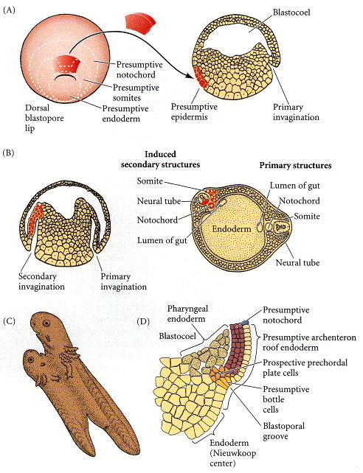

Figure 10.20. Organization of a secondary axis by dorsal blastopore lip tissue. (A) Dorsal lip tissue from an early gastrula is transplanted into another early gastrula in the region that normally becomes ventral epidermis. (B) The donor tissue invaginates and forms a second archenteron, and then a second embryonic axis. Both donor and host tissues are seen in the new neural tube, notochord, and somites. (C) Eventually, a second embryo forms that is joined to the host. (D) Structure of the dorsal blastopore lip region in an early Xenopus gastrula. (A-C after Hamburger 1988; D after Winklbauer and Schürfeld 1999 and Arendt and Nübler-Jung 1999.)

